**ABSTRACT**

The purpose of this project is to outline the creation of an online marketplace that will provide customers especially engineering students of **Everest Engineering College** to find suitable items like notes, books, manuals, drawing drafter scale, college dress for sell, rent or buy it based on their preferences.

We will be using HTML, JavaScript and CSS for user interface, My SQL for database management while Node.JS for server side to build this project.

**Table of Contents**

ABSTRACT.................................................................................................i

LIST OF FIGURE........................................................................................iii

LIST OF TABLES.......................................................................................iv

ABBREVIATIONS......................................................................................v

Chapter 1: INTRODUCTION......................................................................1

1.1 Background and Statement of Problem......................................1

1.2 Objectives and Scope..................................................................2

1.3 Applications................................................................................2

Chapter 2: LITERATURE REVIEW….......................................................3

Chapter 3: METHODOLOGY………………………………………….....4

3.1 System Design............................................................................4

3.1.1 Scrum Model...............................................................5

3.2 Flowchart....................................................................................5

3.3 Hardware and Software required................................................6

3.3.1 PC/Laptops..................................................................6

3.3.2 HTML..........................................................................6

3.3.3 CSS..............................................................................6

3.3.4 JavaScript.....................................................................6

3.3.5 MySQL……………………………………………....6

3.3.6 Node.JS………………………………………………6

3.4 Expected Output.........................................................................7

Chapter 4: FEASIBILITY ANALYSIS........................................................8

4.1 Time Feasibility..........................................................................8

4.2 Financial Feasibility....................................................................8

4.3 Technical Feasibility...................................................................8

4.4 Operational Feasibility................................................................9

Chapter 5: CONCLUSION..........................................................................10

REFERENCES.............................................................................................11

**LIST OF FIGURES**

Figure 3.1.1 Scrum Model ………………………………………… 4

Figure 3.2 Flowchart……………………………………………. 5

Figure 3.4.1 Expected Output ……………………………………. 7

**LIST OF TABLES**

4.1 Gantt Table …………………………………………………… 9

**ABBREVIATIONS**

Prof. : Professor

PC : Personal Computer

HTML : Hypertext Markup Language

CSS : Cascading Style Sheet

IDE : Integrated Development Environment

VS Code : Visual Studio Code

RAM : Random Access Memory

OS : Operating System

CPU : Central Processing Unit

GHZ : Giga Hertz

**Chapter 1: INTRODUCTION**

1. **Background and Statement of Problem**

We have seen and experienced that the students studying engineering whatever faculty might that be or university they had or been studying they must have to study Engineering Drawing.And to study the Engineering Drawing it is compulsory to have the Drafter Scale. Students use that scale for certain semester like one or maximum two semester. After that the drafter scale is just a piece of metal and plastic, it is either hung in wall or just gifted to junior. Same goes to the notes and manuals, after the passing the examination of that subject the note is treated as scrap and it remains under bed till it is sold or gifted to needed one free of cost.

Before writing the proposal on the purposed topic, our group had surveyed students of **Everest Engineering College** about the status of the notes, manuals, college dress, drafter scale they once used for their college studies. Majority, of them had said they had it in their home and would be happy enough to sell or rent those stuffs rather than to gift someone free of cost.

The current problem we want to solve by our project is to make a website through where students of Everest Engineering College find suitable items like notes, books, manuals, drawing drafter scale, college dress for sell, rent or buy it based on their preferences.

1. **Objective and Scope**

To build a user friendly website where we provide customers especially engineering students studying in Everest Engineering College to find suitable drawing drafter scale where they can rent or buy it based on their preferences.

1. **Application**

* Students

Our project will be dealing only with students of Everest Engineering College. So, our main focus will be to facilitate the students through our platform.

**Chapter 2: LITERATURE REVIEW**

Many research projects and papers have already been published by many researchers on Online Shopping, Online Book Store, Online Stationary store in different way to facilitate the users and making them shop from home. Some of the research papers reviews are mentioned below:

In the project made by **C.K. Sunitha and Dr. M. Edwin Gnanadhas** on **ONLINE SHOPPING-AN OVERVIEW** where they have mentioned about the importance of E-Shopping as people are able to buy the products directly from internet sitting in front of their computer. Online stores are usually available 24 hours a day and many consumers have internet access both at work and at home. So it is very convenient for them to shop Online. [1]

According to the project made by **Vamsi Krishna Mummaneni** on **Online Book Store** had mentioned that her project is an online web application where the customer can purchase books online. Through a web browser the customers can search for a book by its title or author, later can add to the shopping cart and finally purchase using credit card transaction. The user can login using his account details or new customers can set up an account very quickly. They should give the details of their name, contact number and shipping address. The user can also give feedback to a book by giving ratings on a score of five. [2]

In the project made by **Rishab Bhat, Prof. Altaf Taher Shah, Prof. Dr. Amol B. Kasture** on **ONLINE STATIONERY STORE** they had mentioned about not having adequate number of stationary store sellers selling their products online. And the prevailing ones are not getting the good response from the users. So, they had built the mobile application where user can explore whole stuffs on the tip of fingers without going to actual store and can pay when they received the package as well as we are providing exclusive feature where they are putting offers on few items for a month and every month items will be updated. In addition, they are giving request option where customer can request new items. [3]

**Chapter 3: METHODOLOGY**

**3.1: System Designing**

## **Scrum Model**

The methodology we will be using to develop this project is the Scrum Methodology which is a subset of Agile Model. As this methodology is the proven for software development as it provides the structure for how to implements agile practices. Scrum is majorly focused on delivering the outcome to the customers in short period of time called **sprints**. Scrum combines four formal events for inspection and adaptation within a containing event, the Sprint. These events work because they implement the empirical Scrum pillars of **transparency, inspection, and adaptation**.

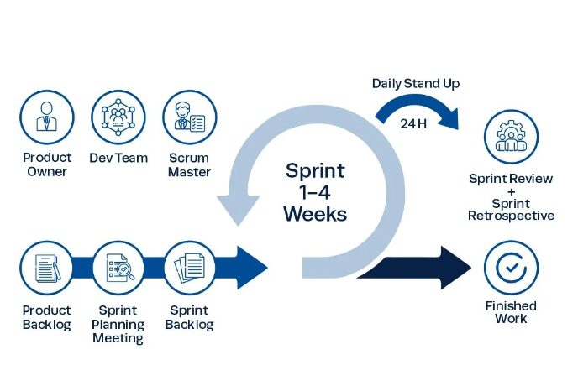

**Figure-3.1.1: Scrum Cycle**

**3.2: Flow Chart**

Flow chart is the pictorial representation of the program flow in sequential order.



**Figure-3.2 Flowchart**

**3.3: Hardware and Software Required**

Hardware components required for our project are:

**3.3.1: PC/Laptop**

**Minimum Requirement:**

* Intel CPU : Quad core 2GHZ or Higher
* Storage : 500 GB SSD
* Graphics : Integrated
* Operating System : Windows 10 64-bit

Software components required for our project are:

## **3.3.2: HTML**

**Hypertext Markup Language** is used for frontend in this project. It is used to create the structure of web page. Without HTML web page would be just jumbled mess of text and images.

## **3.3.3: CSS**

**Cascading Style Sheets** is used to style and layout as it decorates the webpage by making it stylish and attractive. Without it, webpage will be plain text on white background.

## **3.3.4: JavaScript**

We had preferred JavaScript to add interactivity and features to improve the user experience and make our webpage to execute actions.

## **3.3.5: MySQL**

**My Structured Query Language** is the most common standardized language used to access databases. All the data of our websites will be stored in the MySQL server.

**3.3.6: Node.JS**

**Node.js** is an open source, cross platform JavaScript runtime environment. It is designed to build scalable server-side and network applications.

**3.4 Expected Outputs**

The expected output of our project are:



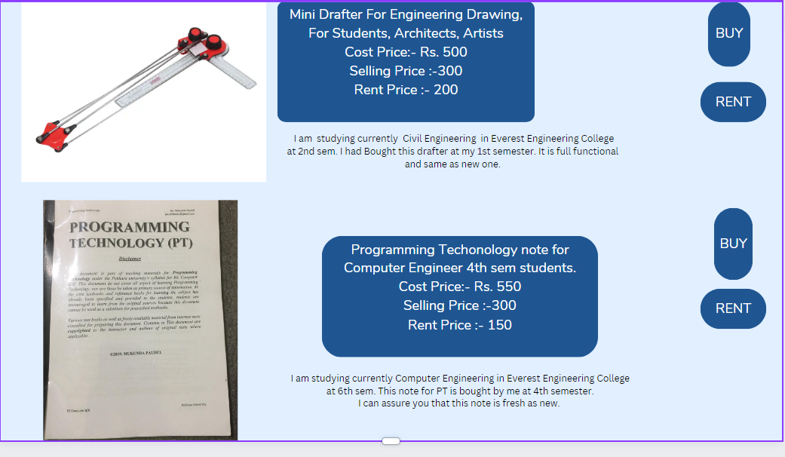

**Figure: 3.4.1 Expected Output**

**Chapter 4: FEASIBILITY ANALYSIS**

Here, we’ve included the project's feasibility, including schedule, financial aspects, technical requirements, and operational considerations. It will help us in future for decision-making and further development of our project.

**4.1 Time Feasibility**

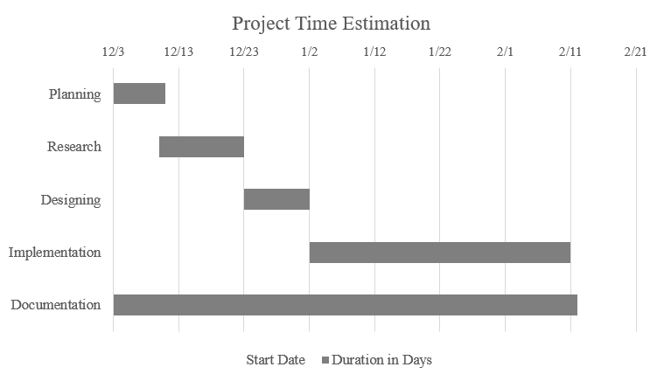

**Table-4.1: Gantt Chart**

**4.2 Financial Feasibility**

Since our project is software based and we do not need any sorts of any hardware components so the cost estimation for our project management is Nrs.1000.

**4.3 Technical Feasibility**

We can strongly say that our project is technically feasible, since there will not be any difficulty in getting required resources for the development of the project. Since, we will be using HTML and CSS for user interface, My SQL for database management while Java script for server side to build this project. And for user internet browser and internet connection would be enough to access this webpage.

**4.4 Operational Feasibility**

To use our system, any there will not be no necessary of trained or professional people, a person with a minimum understanding of the English language can easily operate our system.

**Chapter 5: CONCLUSION**

**‘Everest Deal’** is designed to provide a web based Online Store that would make searching, viewing and selection of the items like notes, drafting scale, college dress, books and any sorts items the students want to buy, rent or sell within in the Everest Engineering College by the students from the students. The user can view the complete specification of each product. They can also view the product reviews and also write their own reviews.

**REFERENCES**

[1] C.K. Sunitha and Dr. M. Edwin Gnanadhas on ONLINE SHOPPING-AN OVERVIEW

<https://www.researchgate.net/publication/264556861_Online_Shopping_-_An_Overview>

[2] Vamsi Krishna Mummaneni on Online Book <https://people.cs.ksu.edu/~vamsim/vamsi_Report_Draft1.pdf>

[3]Rishab Bhat, Prof. Altaf Taher Shah, Prof. Dr. Amol B. Kasture on ONLINE STATIONERY STORE

<https://www.ijirmps.org/special-issues/1/17.pdf>

[4] <https://www.youtube.com/watch?v=6fKn4rgk4jM>

[5] <https://www.scribd.com/document/484796847/final-ecommerce-report-docx>

[6] <https://www.coursehero.com/file/60608594/hamrobazarpdf/>

[7] <https://blogs.ntu.edu.sg/hp3203-1819s2-u17/conclusion/>

[8] https://scrumguides.org/scrum-guide.html/